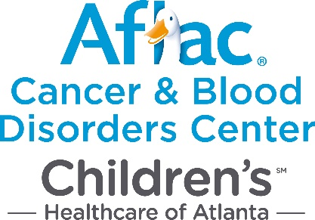

Please check one:
I am an:

- Aflac Employee
- Friend of Aflac
- Aflac Associate - Market Operation: ____________________________

My gift is a(n):

- General Contribution to the Aflac Cancer Center
- Memorial Gift* to the Aflac Cancer Center -- in memory of
- Honorarium* to the Aflac Cancer Center -- in honor of

Please provide the following information:

Donor Name(s):
Address:
City, State, Zip:
Phone Number: ( ) Email:

Amount $
Aflac Writing Number:________________ Number of Monthly Deductions:____________

- If gift is in memory of or in honor of someone, please provide the following information:

Name(s) to notify:
Address:
City, State, Zip:

If you elect to make a gift in honor of or in memory of an individual(s), the amount will not be disclosed to the party to be notified. Your gift will be acknowledged in accordance with your instructions. This is a meaningful and lasting way to remember an anniversary, birthday, and graduation, recovery from an illness, bereavement or other occasion. A minimum gift of $25 per tribute name is requested.

Please make all checks payable to Aflac Cancer Center and return to the following address.

Aflac Cancer and Blood Disorders Center
ATTN: Alex Faas
1575 Northeast Expressway
Atlanta, GA 30329

Your contribution is tax deductible as provided by law.

