Miscellaneous Donation Form
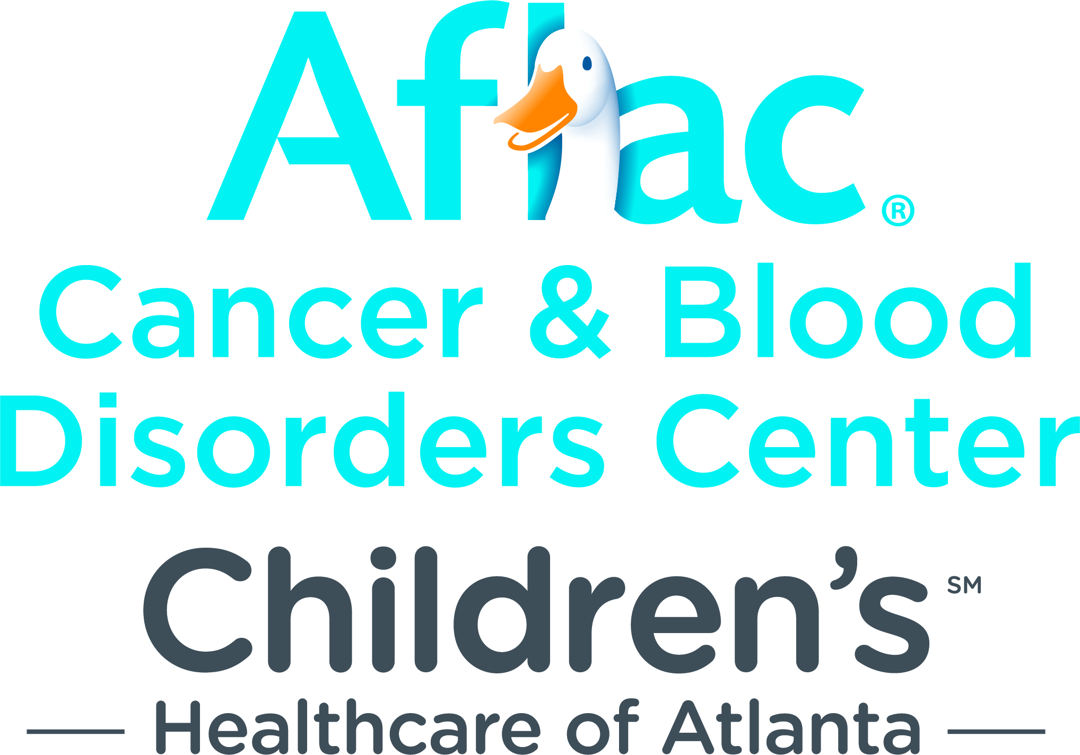
(For use with auctions, special fundraising events
and donations for a specified period of time)

Aflac/Aflac NY Independent Contractor

Description of Item Purchased: _

Total Donation Amount: $______________ Number of Monthly Deductions:

Amount of Each Deduction: $ Fair Market Value: $

Donor Information:

NAME: Market: _________

Writing or Employee Number: Cell Phone Number:

Aflac/Aflac NY E-mail Address: _____ ________________________

As a 1099 independent contractor, I voluntarily choose to authorize and direct Aflac or Aflac New York, to the extent permitted by law, to deduct the amount listed above per month from my earned commission as shown on my monthly accounting statement and to transfer, on a periodic basis, such deductions as my contribution to the Aflac Cancer and Blood Disorders Center of Children's Healthcare of Atlanta. I acknowledge that Aflac or Aflac New York has agreed to make requested deductions for my convenience and that of the Aflac Cancer and Blood Disorders Center so long as my statement balance is sufficient to cover any or all of my contribution amount. I understand that the 1099 form provided by Aflac or Aflac New York will continue to include my contributions as part of my gross commission income and that I am responsible for determining whether I may be entitled to report any tax deduction for those contribution amounts. I understand my donation will be used to support the Aflac Cancer Center of Children’s Healthcare of Atlanta.
Important Notes:
- All experiences purchased at auctions must be redeemed within one year of the date of purchase.
- Neither Aflac nor Children's Healthcare of Atlanta make any warranties or representations as to the items or experiences purchased.
- Your purchase of this auction item and/or experience is final.
- This authorization to debit your earned commissions is irrevocable and shall remain in full force and effect until full payment has been made.
- Please keep a copy of this information for your reports. Your tax deductible donation to Children's Healthcare of Atlanta is the amount paid above the fair market value of the item.

______
Signature Date

Please mail or email this form to:

Aflac Cancer and Blood Disorders Center
1575 Northeast Expressway
Atlanta, GA 30329
404-785-9402
Alex.Faas@choa.org

