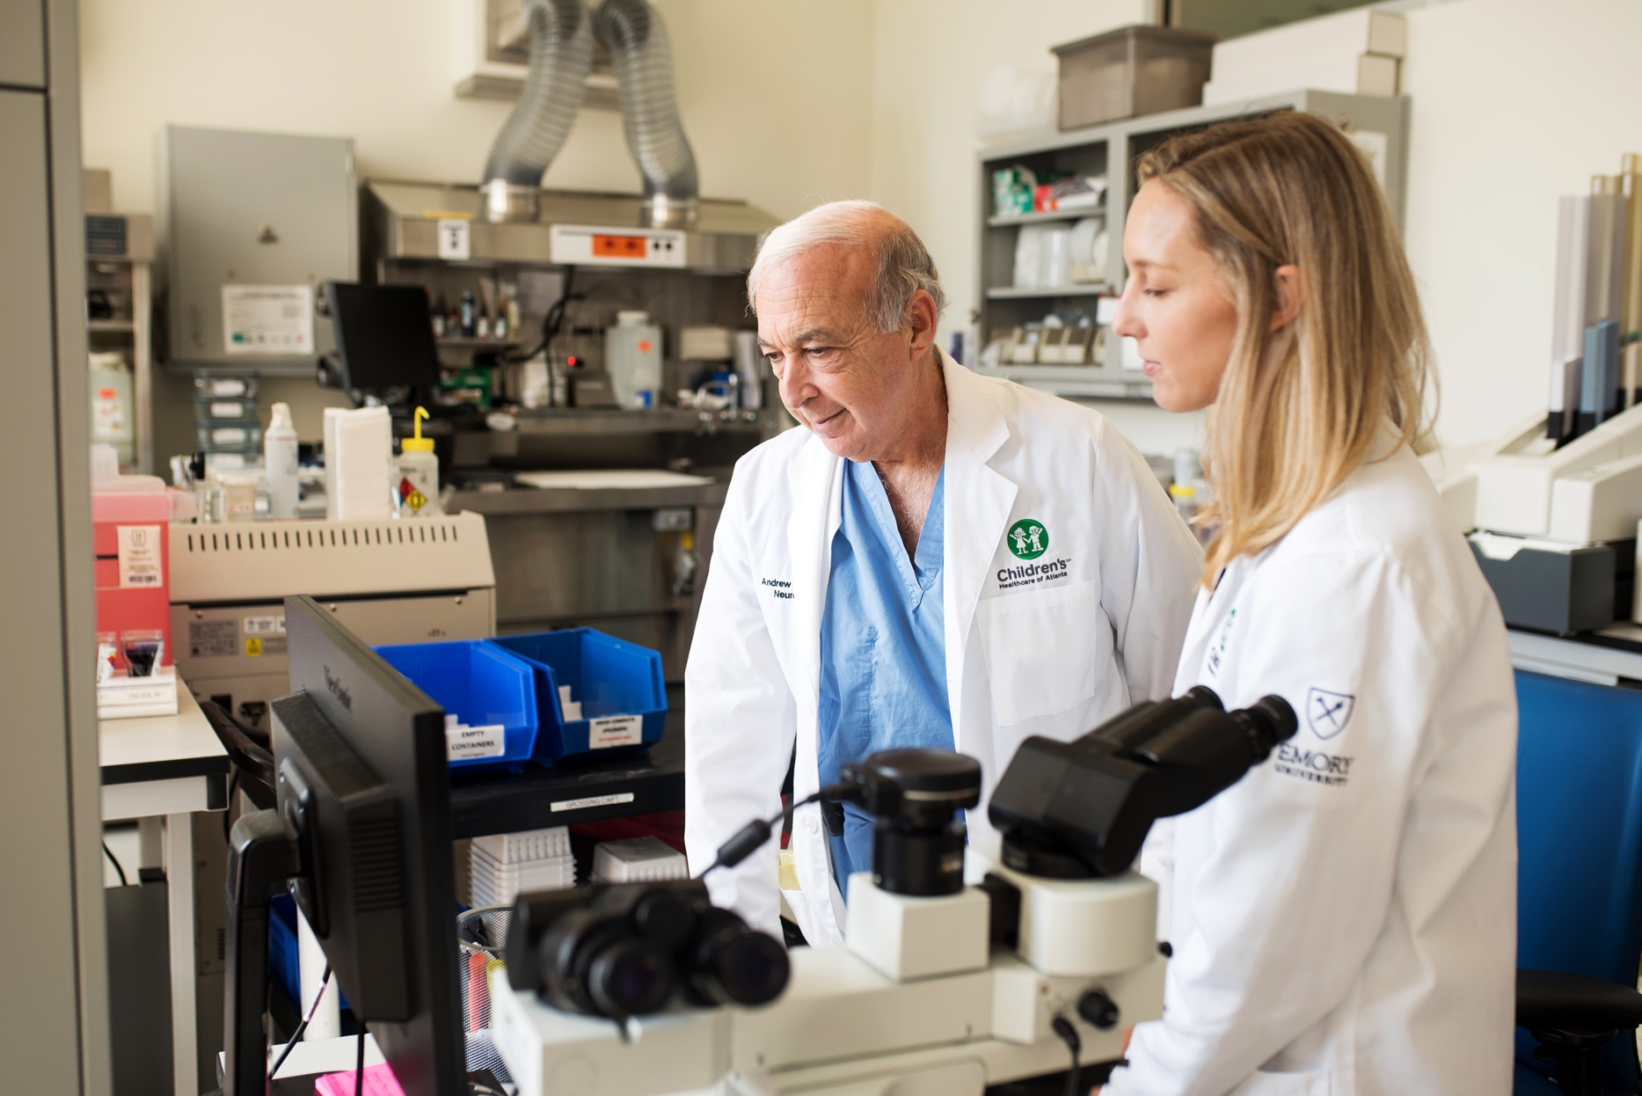

Study contact information

• choa.org email address

• Phone number

**Compensation (121 character limit)**  
Include if applicable, toribus daeptatem ratur, volorend quidipsam vel mi, officat lumqui blam sum volum

**Beginning and end date of recruitment (135 character limit)**  
quati unt aute et latquid quo et lique ime nesedipis dolor aut maximil luptibus maio qua

**Location of study**

• Campus toribus daeptatem ratur, volorenda quidipsam vel   
 mi, officat

• Address toribus daeptatem ratur, volorenda quidipsam vel mi, officat iumqui blam

• Parking information toribus daeptate ratur, volorendaquidip   
vel mi, officat iumqui blamm vel mi, officat iumqui blam sum volum utatem fugitium quidisq uiassi

**Purpose of study (330 character limit)**  
re, optate videllatus mint eum fugitincia cusapient atur ratiam quati unt aute et latquid quo et lique ime nesedipis dolor aut maximil luptibus maio quamus, toribus daeptatem ratur, volorenda quidipsam vel

• What will be assessed and why?m vel mi, officat iumqui blam sum volum utatem fugitium quidisq uiassi

**Participant eligibility (245 character limit)**

• Age

• Diagnosis m vel mi, officat iumqui blam sum volum utatem fugitium quidisq uiassi

• Caregiver requirements toribus daeptatem ratur, volorenda  
quidipsam vel mi, officat iumqui blam sum volum utatem fugitium quidisq uiassi

**Benefits of participation (225 character limit)**

• Describe any potential benefits of study participation. Do   
 not refer to financial compensation or free drugs/treatment   
 as a benefit. Atur ratiam quati unt aute et latquid quo et   
 lique ime nesedipis dolor aut

Official title of study

**Clinical trial recruitment**

2022 Children’s Healthcare of Atlanta. All rights reserved. EC 000000. Ab. 00/00